**PIZZA SALES SQL QUERIES**

**A. KPI’s**

**1. Total Revenue:**

SELECT SUM (total price) AS Total Revenue FROM pizza sales;

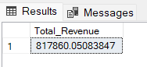

**2. Average Order Value**

SELECT (SUM (total price) / COUNT (DISTINCT order_id)) AS Avg_order_Value FROM pizza sales

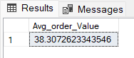

**3. Total Pizzas Sold**

SELECT SUM (quantity) AS Total_Pizza_Sold FROM pizza sales

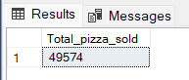

**4. Total Orders**

SELECT COUNT (DISTINCT order_id) AS Total Orders FROM pizza sales

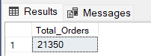

**5. Average Pizzas Per Order**

SELECT CAST (CAST (SUM (quantity) AS DECIMAL (10,2)) /

CAST (COUNT (DISTINCT order_id) AS DECIMAL (10,2)) AS DECIMAL (10,2))

AS Avg_Pizzas_per_order

FROM pizza sales

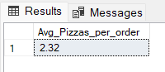

**B. Daily Trend for Total Orders**SELECT DATENAME (DW, order date) AS order day, COUNT (DISTINCT order_id) AS total orders

FROM pizza sales

GROUP BY DATENAME (DW, order date)

***Output:***

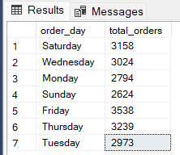

**C. Monthly Trend for Orders**

select DATENAME (MONTH, order date) as Month Name, COUNT (DISTINCT order_id) as Total Orders

from pizza sales

GROUP BY DATENAME (MONTH, order date)

***Output***

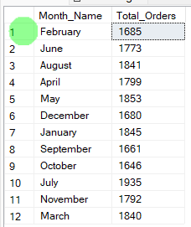

**D. % of Sales by Pizza Category**

SELECT pizza category, CAST (SUM (total price) AS DECIMAL(10,2)) as total revenue,

CAST (SUM (total price) * 100 / (SELECT SUM(total price) from pizza sales) AS DECIMAL(10,2)) AS PCT

FROM pizza sales

GROUP BY pizza category

***Output***

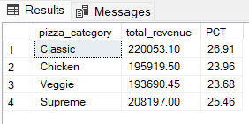

**E. % of Sales by Pizza Size**

SELECT pizza size, CAST (SUM (total price) AS DECIMAL (10,2)) as total revenue,

CAST (SUM (total price) * 100 / (SELECT SUM(total price) from pizza sales) AS DECIMAL(10,2)) AS PCT

FROM pizza sales

GROUP BY pizza size

ORDER BY pizza size

***Output***

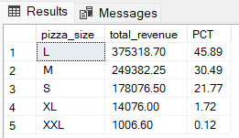

**F. Total Pizzas Sold by Pizza Category**

SELECT pizza category, SUM (quantity) as Total_Quantity_Sold

FROM pizza sales

WHERE MONTH (order date) = 2

GROUP BY pizza category

ORDER BY Total_Quantity_Sold DESC

***Output***

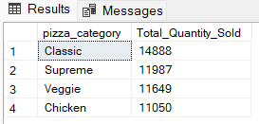

**G. Top 5 Pizzas by Revenue**

SELECT Top 5 pizza name, SUM (total price) AS Total Revenue

FROM pizza sales

GROUP BY pizza name

ORDER BY Total Revenue DESC

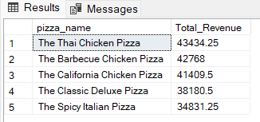

**H. Bottom 5 Pizzas by Revenue**

SELECT Top 5 pizza name, SUM (total price) AS Total Revenue

FROM pizza sales

GROUP BY pizza name

ORDER BY Total Revenue ASC

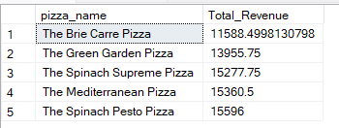

**I. Top 5 Pizzas by Quantity**

SELECT Top 5 pizza name, SUM (quantity) AS Total_Pizza_Sold

FROM pizza sales

GROUP BY pizza name

ORDER BY Total_Pizza_Sold DESC

***Output***

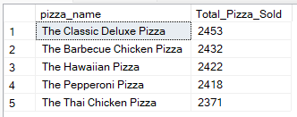

**J. Bottom 5 Pizzas by Quantity**

SELECT TOP 5 pizza name, SUM (quantity) AS Total_Pizza_Sold

FROM pizza sales

GROUP BY pizza name

ORDER BY Total_Pizza_Sold ASC

***Output***

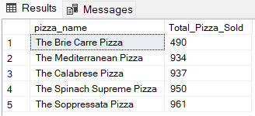

**K. Top 5 Pizzas by Total Orders**

SELECT Top 5 pizza name, COUNT (DISTINCT order_id) AS Total Orders

FROM pizza sales

GROUP BY pizza name

ORDER BY Total Orders DESC

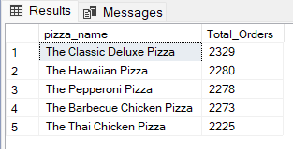

**L. Bottom 5 Pizzas by Total Orders**

SELECT Top 5 pizza name, COUNT (DISTINCT order_id) AS Total Orders

FROM pizza sales

GROUP BY pizza name

ORDER BY Total Orders ASC

